

**Graduation Project Report “Car Sanitizer”**



**Project’s Team:**

* Dr. Nashat Ghaleb Albdour
* Abdullah Husam Abed Al-Dirie
* Tareq Khaled Almarahleh

**Tafila Technical University**

**Engineering college**

**Department of communications and electronics engineering**

**2020/2021**

**The main idea of the project:**

After the COVID-19 pandemic, the need for sanitizers had increased. Nowadays, every single place have to have a sanitizer bottle to keep ourselves protected from the Corona virus.

We want to build a mini car with an attached sanitizer which can be driven by smart phone. The purpose of this car is to move in small places like conferences and houses’ guest rooms to supply sanitizer for people. No need for anyone to even touch the bottle, the person who drive the car via mobile app should be able to control a shaft which push the sanitizer’s head.

**The working principle of the project:**

Using an Arduino and a Bluetooth chip in the car, we can link a smart phone using an app to that car. The driver –person who control the car- should be able to move it around the place and offer a sanitizer to every person in the place without touching or even get close to anyone of them.

Controlling the sanitizer via Bluetooth is only a spare procedure in case the following primary controlling method did not work. We will install a laser unit to the car to activate the shaft that pushes the sanitizer. That unit consists of a laser diode pointing on an LDR (Light Dependent Resistor). When someone cross that laser, the Arduino will rotate the shaft (Servo motor) to push the sanitizer.

An additional components on the car may provide better look and efficiency. We can install an Ultrasonic sensor (distance sensor) to alert the driver with a Buzzer if the car is about to bump an obstacle. RGB LED should give clear indicators about the car state.

**The needed components:**

* Arduino Mega.
* Bluetooth chip HC-05
* Breadboard
* LASER diode
* LDR
* Ultrasonic sensor
* RGB LED
* Servo motor
* 12V Battery
* H-Bridge module L298N
* 4 Gearmotors with wheels
* Jumper wires
* A bottle of sanitizer

The mobile application should be found on the “Google Play” store

**3D visualization of the final project:**

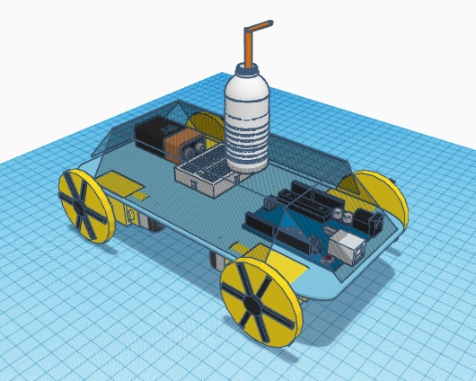

This is just an initial design, the rest of the components should be added to the case

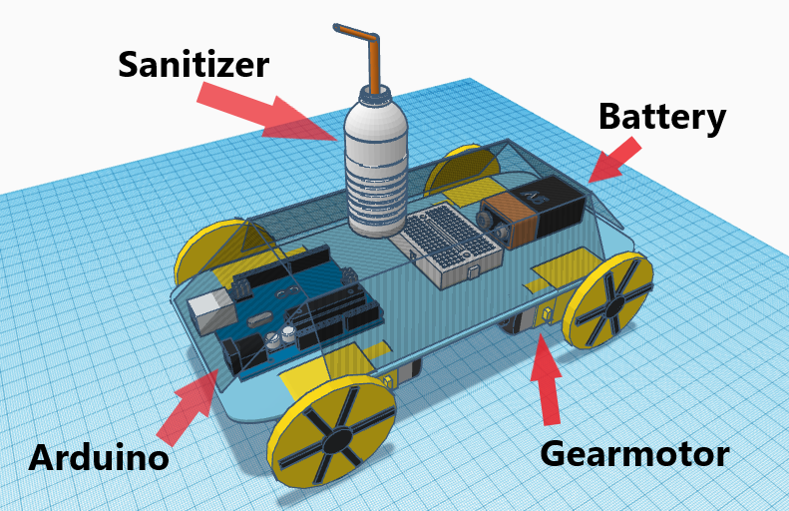

And this is an initial case of the car:

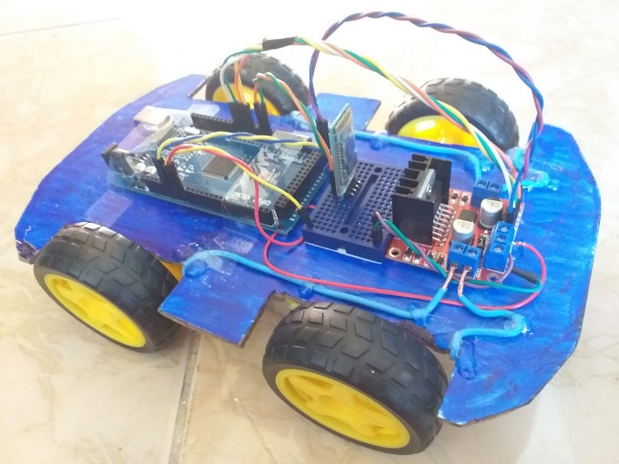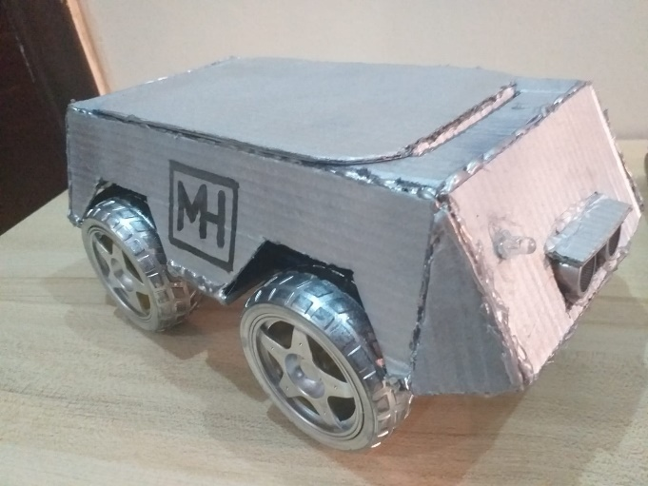

**Appendix**

**A link to the 3D design on Tinkercad:**

<https://www.tinkercad.com/things/4Ar47hbXFVK-neat-migelo-jaiks/edit?sharecode=yb74IVnf5cVSwIU3UEQwuSZbnKA4a9EXZFBUFmKcwxc>

**A link to the online store where we will buy the components:**

[**https://www.plusivo.jo/**](https://www.plusivo.jo/)

**Team contact:**

* **Team leader : +962795929730**